Signal & Detection
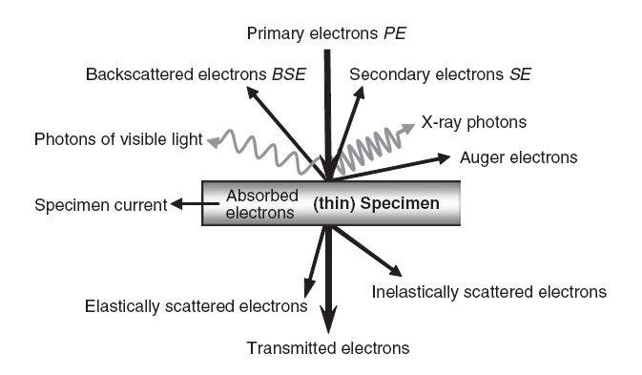
- Backscattered Electrons
- Secondary Electrons
- X-rays
Depending on the signal type various characteristics of sample such as chemical composition, surface topography, phase distribution, and crystallinity can be determined.
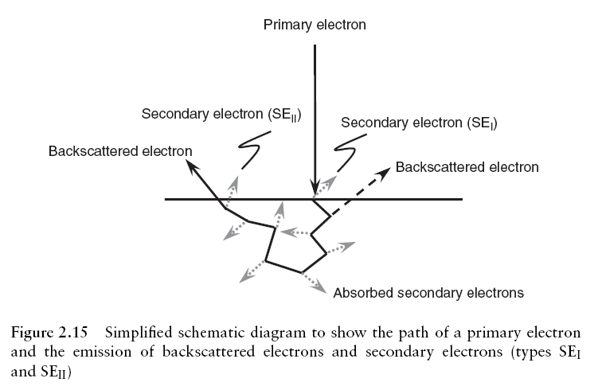
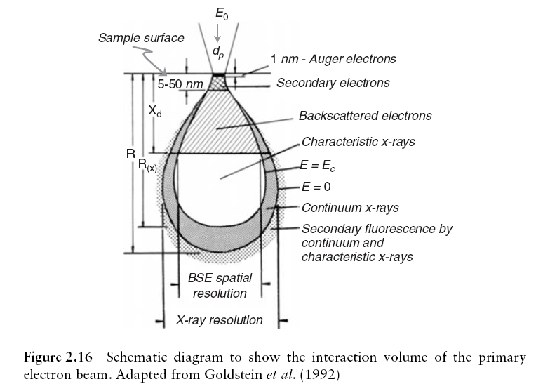
- The range and escape depths of signals vary according to the type and energy of interactions.
- The size and shape of the interaction volume varies as a function of both the energy of primary beam and nature of the sample.
- A primary electron makes random elastic or inelastic collisions until either it loses all the energy and comes to rest within the sample, also called thermalization or it reaches a boundary of the sample and is emitted as a back scattered electrons or as a transmitted electrons (if using thin sample).
- Each signal originates from a special volume within the sample, potentially yielding sample characteristics such as chemical composition, surface topography, phase distribution and crystallinity.
- Figure shows path of primary electrons and emission of BSE’s and secondary electrons.
- Figure shows the range (i.e. length) and spatial distribution within a region of sample (interaction volume) characterizing various signals that can be produced by an electron beam.
- The range and escape depths of signals vary according to the type and energy of interaction.
- The size and shape of the interaction volume varies as a function of both the energy of primary beam and nature of the sample.

Dependence of interaction volume on primary electron energy
- Low energy primary electron is more likely to undergo collision with an atom of the sample, since it moves more slowly than a high energy electron.
- Also low energy electrons lose energy at faster rate.
- The distances between collisions (mean free path) and penetration depth of primary electrons into the sample are smaller when beam energy is low and so interaction volume is also smaller.

Dependence of Interaction volume on Atomic No.
- Primary electrons penetrating a material with a low atomic number have longer mean free path λ, than electron with the same energy in a material with high Z.
- This is due to consideration of the Coulombic attraction of the nucleus, where a higher atomic number leads to a greater Coulombic attraction.
- Therefore, electrons of a given energy undergo a greater degree of elastic scattering/unit length with high Z materials reducing the size of interaction volume.
- Scattering angles are also high.

Beam penetration- Decreases with Z of material.

Backscatterd Electrons
Primary electrons that have been deflected by collisions with atoms to such an extent that their path actually takes them back up through the sample surface.
- They can be emitted from deep within the sample. Depending on collision history BSE energies can range from primary beam energy E₀ down towards level of secondary electrons.
- However, there are 2 distinct regions in the energy distribution of BSE’s.
- Region I is attributed to electrons that have retained ≥ 50% of the primary beam energy.
- Materials of intermediate and high Z have high proportion of BSE’s in this region.
- Region II is a broad tail of energy distribution representing primary electrons that have travelled progressively farther into the sample losing energy (inelastically) before being back scattered (elastically) out of the sample.
- Lower energy limit associated with BSE’s is arbitrarily taken to be 50 eV.
- The BSE coefficient η is ratio of number of BSE’s emitted η_{BSE} to number of primary electrons bombarding the sample η_{PE} (or their equivalent current i).
η = η_{BSE} / η_{PE} = i_{BSE}/i_{PE}
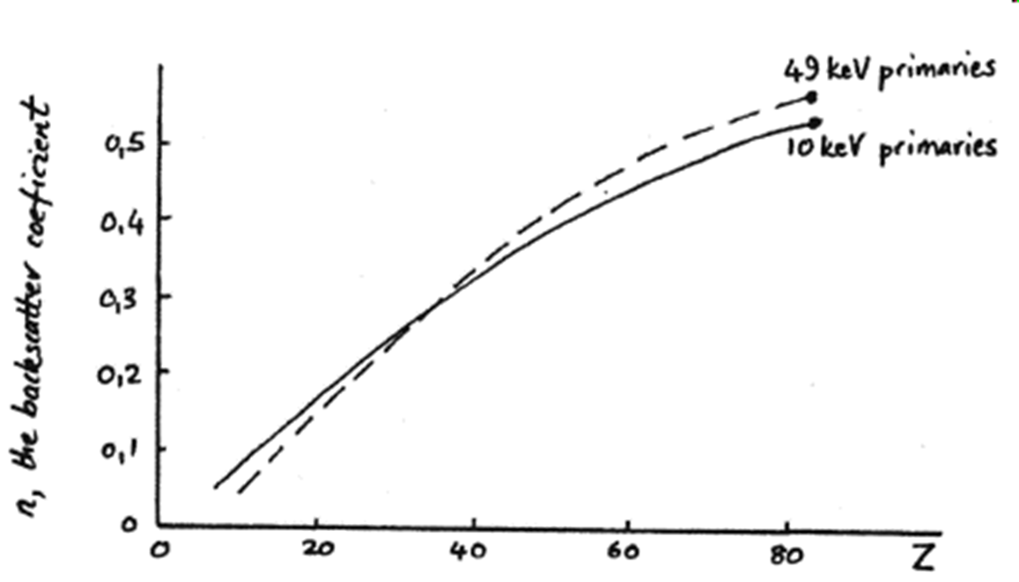
- The BSE coefficient is found to increase smoothly and monotonically with Atomic number (Z) for a given angle of incidence. This dependence on Z provides an imp contrast mechanism in SEM enabling different materials to be distinguished.
- BSE also changes with angle θ of sample, and the reason for this originates from the geometry of the escape depth relative to the incident primary beam. This behaviour serves as a imp contrast mechanism, in that different topographical features can again be distinguished on the basis of variations in η. (a flat surface having a lower coefficient than a sloped surface or edge).
- The value of η is relatively in sensitive to primary beam energy (above 5 Kev) due to 2 competing factors. As the beam energy E₀ increases the probability of elastic scattering of the primary beam is reduced. One might therefore expect the value of η to be correspondingly lower with increasing beam energy.
However, scattered electrons with high initial energy lose energy at a lower rate (/unit length of material) than scattered electrons with lower energy. Backscattered electrons with higher energy are less readily absorbed by the sample than the low energy backscattered electrons/ therefore, net result is that η remains roughly the same at a variety of beam energies.
Secondary Electrons
- Secondary electrons excitations result when loosely bounded valence electrons are promoted from the valence band to the conduction band in insulators and semiconductors or directly from conduction band in metals. These excited electrons then propagate through the sample, experiencing inelastic collisions and energy loss themselves.
- Once at sample surface the electrons can be emitted as a secondary electrons, Low energy secondary electrons are arbitrarily defined as having energies less than 50 eV, with majority having energies < 10eV. Typical energy distribution is as in figure .
- The general distribution is same for all materials, although the maximum value of the emission coefficient and the energy at which this occurs varies.
- The coefficient for secondary electrons is defined as the ratio of number of SEs’ emitted to number of primary electrons η_{PE} bombarded on the sample (or their equivalent current i)
ɗ = η_{SE} / η_{PE} = i_{SE}/i_{PE}
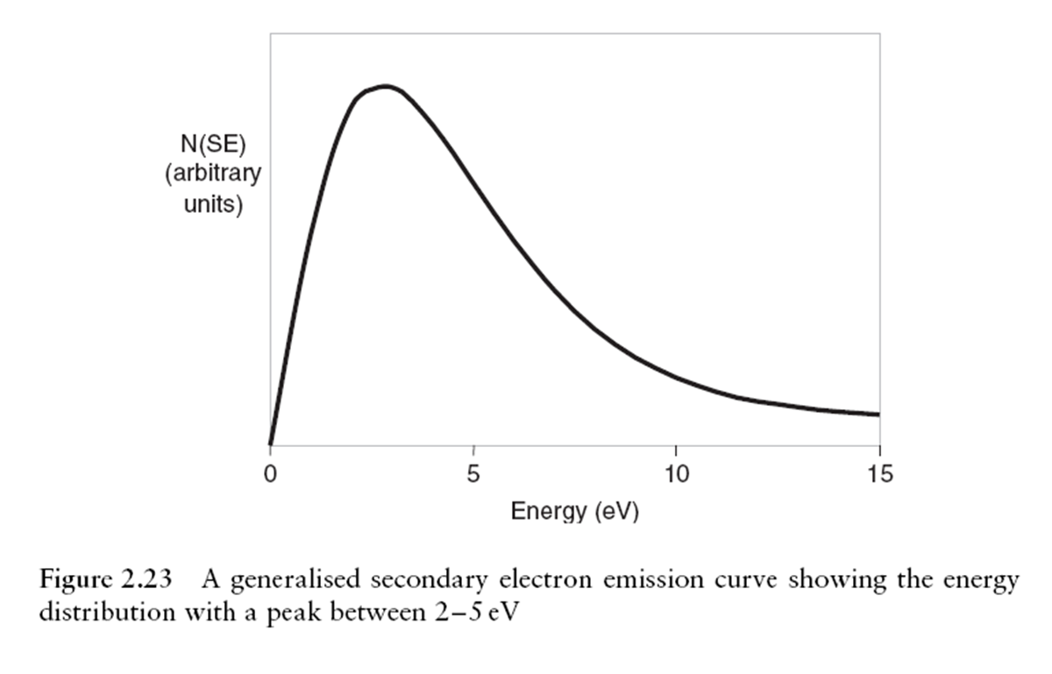
- Unlike BSE ɗ here is relatively insensitive to Z. Typical value of ɗ is therefore 0.1 for most elements, for C; ɗ = 0.05 and Au; ɗ = 0.2
- Because of their low energies, excited electrons travel only short distances, a few nanometers. Therefore SEs’ that emerge from the sample must originate close to the surface.
- The signal from SEs’ thus provides information about the surface of the sample and is the principal signal used for topographical information in SEM.
- The probability of SE escape decreases exponentially with depth Z as a result of strong attenuation of secondary electrons by inelastic scattering.
Ρ ≈ exp^{–Z/λ}
λ = mean free path of excited electrons as they propagate through the sample towards the surface.
- The mean free path is equivalent to the mean depth of emission (mean escape depth) of SEs’. The value of λ is said to be about 1 nm in metals and upto 20 nm in insulators.
- The maximum depth of emission T, is taken to be ~ 5 λ. Inelastic scattering of SE’s by condting electrons which are abundant in metals leads to reduction of λ for metals. The mean escape depth of SEs’ is around 1/100 that of BSE’s. Once at the surface, secondary electrons must have sufficient. Energy to overcome the work function of the sample.
- Similar to η, ɗ is dependent on tilt angle of sample and primary beam energy to some extent. At high beam energies (10-30 kev), ɗ is well below 1. However, as the beam energy is lowered to ~ 5 kev the total electron yield (ɗ+η) begins to rise. As η is insensitive to beam energy, the increase in yield is attributed to increase in ɗ.
- The point at which total yield reaches 1 is termed as the 2nd crossover point E₂. At lower energies the yield can actually become greater than 1 i.e. more electron are emitted by sample than supplied.
- At low beam energies the total yield falls below 1 once again and this is called 1st crossover. Point E₁ (not to be confused with beam crossover). The total yield behaviour as a function of primary beam energy E₀ is shown in Figure.
- This can be explained in relationship between the penetration of primary beam and escape depth of SEs’.
- When beam energy is below 5 kev the interaction volume is small and primary electrons are more strongly attenuated by scattering. The interaction volume becomes very shallow between E₁ and E₂ that many electrons crated by primary beam are within are within escape depth of the sample and thus greater proportion are able to escape as SE’s.
- There are a number of sources of SEs’signal emitting from the sample and its surroundings in the SEM sample chamber.
- Most relevant are SE_{I} and SE_{II}.
SE_{I} = Originate from sample surface at the point of impact by primary electron beam. This is the most important SE imaging signal as it gives the highest resolution.
SE_{II} = Produced by BSE’s as they exit the sample surface. For a low Z target such as C the SE_{II} signal is approximately 1/5th that of SE_{I} signal. For high Z target such as Au, the SE_{II} signal becomes 1.5 times larger than the SE_{I} signal.
- The total SE coefficient ɗ_{T} is thus a function of both the true SE_{I} coefficient ɗ_{SEI} and BSE dependent SE_{II} coefficient ɗ_{SEII}^{ηi}
ɗ_{T =} ɗ_{SEI +} ɗ_{SEII}^{η}
Because η is virtually independent of beam energy the total number of SE_{II} remains roughly constant with increasing beam energy. However, there is a lateral spread in the interaction volume of BSE. This increases the spatial distribution SE_{II.} They may be liberated some distance away from the point of interest.
- Other types of SE are formed as BSE’s strike the walls of the chamber and primary electrons strike the polepiece. These are sometimes referred to as SE_{II.}

X-ray Radiations
- These are emitted as a result of the relaxation of an excited state in an atom. The initial excited state is caused by the ionization of a tightly bound inner electrons by an incident primary electrons. Process shown in Fig.
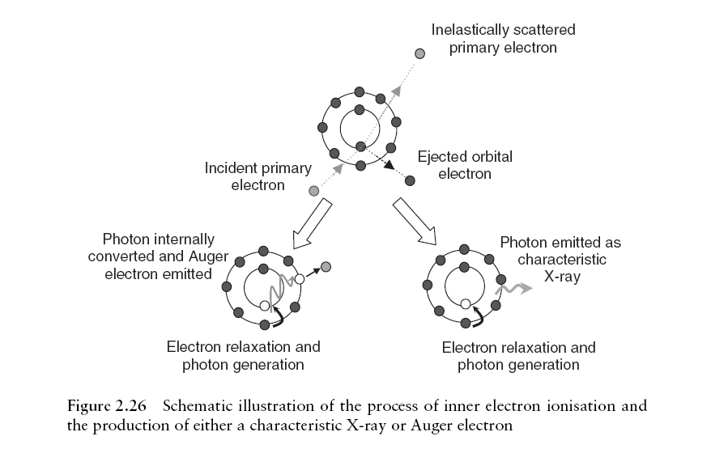
- Such signals are very useful for deducing the chemical composition of materials and chemical characterization in the electron microscope is known as micro analysis to distinguish from imaging.
- Most common form of X-ray microanalysis is called as X-ray spectroscopy, abbreviated to EDX or EDS. An alternative form of microanalysis is called as wavelength dispersive X-ray spectroscopy, WDS.
_{Detectors}
- Secondary electrons are low energy electrons.
- We can easily collect them by placing a positive voltage (100- 300V) on the front of our detector.
- This lets enables to collect a large number of the secondary e- (50 - 100%), a“3D” type of image of the sample with a large depth of field is produced.
- The type of detector used is called a scintillator / photomultiplier tube.
Scintillation Detector
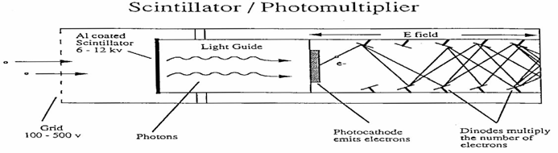
- Secondary electrons (SE) are accelerated to the front of the detector by a bias voltage of 100 - 500 eV.
- They are then accelerated to the scintillator by a bias of 6 - 12 keV, (10 KeV is normal).
- Scintillator is doped plastic or glass covered with a fluorescent material (e.g. Europium). A thin (700Å) layer of Al covers it to prevent light from causing fluorescence.
- The 10keV potential allows the SE to get through the Al and fluoresce.
- The light photons travel down the tube (guide) to a photocathode which converts them into electrons.
- The electrons move through the detector, producing more electrons as they strike dynodes. An output electron pulse is then detected.

Surface Barrier Detector
- Since BSE have high energies, they can’t be pulled in like secondary e⁻. If a potential applied on a grid to attract them, they would also attract the incident beam!!
- The most common detector used is called a surface barrier detector. It sits above the sample, below the objective lens. BSE which strike it are detected.
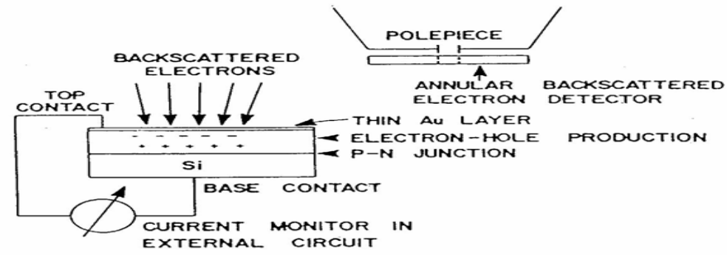
- Surface barrier detectors are solid state devices made up of semiconducting materials. A semiconducting material has a filled valence band and an empty conduction band- similar to ceramic materials.
- When a BSE electron strikes the detector, electrons in the material move from valence to conduction band.
- The electrons are now free to move in the conduction band or drop back into the valence band.
- If a potential is applied, the e- and e+ can be separated, collected, and the current measured. The strength of the current is proportional to the number of BSE that hit the detector.
Everhart Thornley Detector
- Detector that can measure or SE and BSE’s
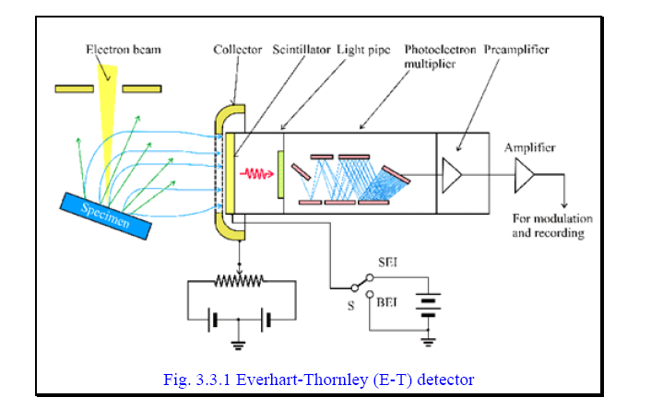
- The secondary electrons are accelerated to ~ 10 kV by a bias voltage applied on the front surface of the scintillator.
- A flash of light is produced when the accelerated secondary electrons strikes the scintillator.
- The light flashes are then detected and amplified by a photomultiplier tube.
- The scintillator is surrounded by a metal grid collector normally biased to a positive potential of a few hundred volts.
- The low potential of the collector prevents the high potential at the scintillator surface from affecting the primary beam.
- At the same time, it is sufficient for pulling the low energy secondary electrons towards the detector.
By applying a negative voltage on the collector, secondary electrons are repelled and backscattered electrons travelling towards the detector are selected.
X-ray detector: Electron dispersive X-ray spectrometer (EDX)
- The solid state X-ray detector is composed of a thin silicon crystal doped with lithium so that the central intrinsic region is sandwiched between a thin p-type layer and a thin n-type layer.
- Thin gold electrodes were deposited on both crystal surface and potential is applied to make the p-i-n junction reversed biased.
- In the absence of X-ray photons, the current through the crystal is very small.
- When an X-ray photon hits the detector, it produces a large number of electrons and holes in the Si(Li) region.
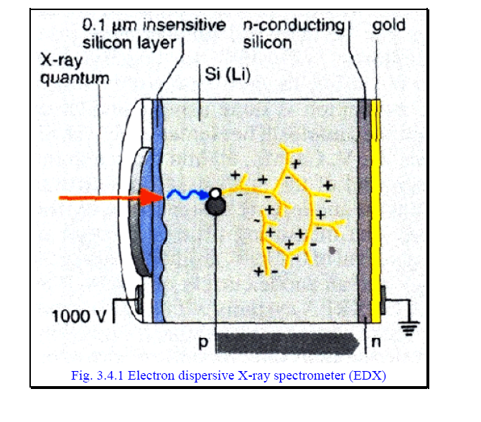
- Thus, a pulse of current is generated. The pulse current is proportional to the X-ray energy.
- In operation, each current pulse is analyzed to determine the energy of the incident photon.
- The count for photons within a small energy range is stored in one channel of a multichannel analyzer.
- The X-ray signal is accumulated for a predetermined period of time and the X-ray counts accumulated in the multichannel analyzer constitutes an X-ray spectrum from the specimen.
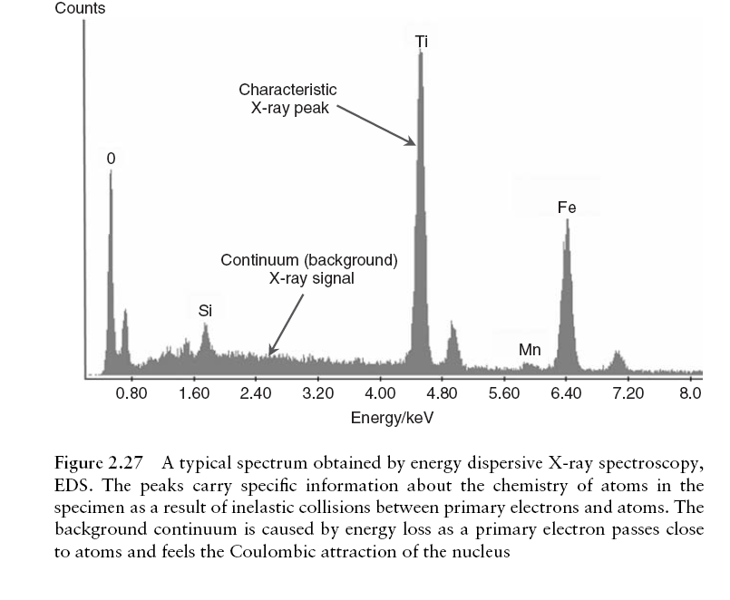
Sample Holders
Many types are available
- Universal Sample Holder for SEM
- Vertical Mount holder for thin samples
- First Stage Copper Sample Holder
- Multipin Sample Holder
- Variable Tilt Holders
- Compact Variable Tilt Mount
Universal Sample Holder for SEM


Vertical Mount holder for thin samples

First Stage Copper Sample Holder

Multipin Sample Holder

Variable Tilt Holders

Compact Variable Tilt Mount

Multipurpose /Bulk Holders
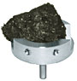
Angled pin stub holder


